(11) Create multiple testing plan templates (different tools for each, i.e. sheets, docs, etc.), describe what it is, and demonstrate how to use the template for testing computer programs. (B4.4).

Example Problem(s) [1]:

<https://dmoj.ca/problem/ccc25j2>

What is a test plan [2]:

* Encapsulates the goal, process, cases, and constraints of a program
* Assists in documenting steps, milestones, and optimizations
* Details test approaches and methods to identify errors/mistakes
* Divides processes between group members if applicable
* Write tests before programming removes testing bias

Types of plans [3]:

Proactive (better) - Create test cases first and start programming with those in mind

Reactive - Run and debug, writing test cases along the way

Steps (Proactive) [4][5]:

1. Identify the software (languages, interfaces, IDE, tools) used to develop and access
2. Identify constraints/scope of program (accepted input and outputs) and edge cases

* Edge cases are inputs which approach the boundaries of the constraints

1. Create very specific test cases (For a certain input, what is the desired output)

* Each test case should have an intention to possibly identify points of improvement or implementation
* At least two test cases per interaction/feature to verify consistency
* Identify what will be tested, who will test it, when should it be tested and how
* Tests should culminate in an overarching goal
* E.g.

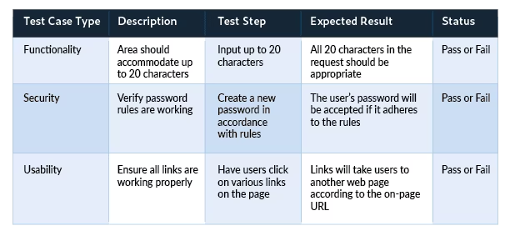

1. Start developing the code whilst continually testing

* Code should follow the test case explicitly
* Implement the code to fit the test cases
* Continue until code is perfected

References

[1] DMOJ, “CCC ’25 J2 - Donut Shop - DMOJ: Modern Online Judge,” *DMOJ: Modern*

*Online Judge*, 2025. https://dmoj.ca/problem/ccc25j2 (accessed Mar. 21, 2025).

[2] K. Passby, “How to Create a Test Plan For Software Testing,” *www.wearedevelopers.com*, Sep. 22, 2021. https://www.wearedevelopers.com/magazine/how-to-create-a-test-plan-for-software-testing

[3] Wikipedia Contributors, “Test plan,” *Wikipedia*, Sep. 26, 2019. https://en.wikipedia.org/wiki/Test_plan

[4] D. Harder, M. Math, Patel, and W. Dietl, “ECE 150 Fundamentals of Programming Writing tests,” 2020. Accessed: Mar. 21, 2025. [Online]. Available: https://ece.uwaterloo.ca/~ece150/Lecture_materials/pdfs/1.21%20Testing.pdf

[5] S. Bose, “How to write Test Cases (with Format & Example),” *BrowserStack*, May 09, 2024. https://www.browserstack.com/guide/how-to-write-test-cases